**Task 1**

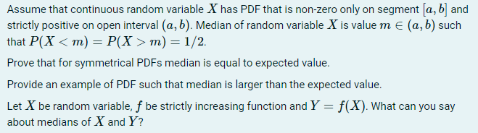

* As $PDF_{X}$ is symmetrical on segment $\left[a,b\right]$, it’s symmetric about the middle value of this segment $\frac{a+b}{2}$.

$P\left(X<m\right)=P\left(X>m\right)=1/2$ means that half of the values of X are less than m and the other half is greater than m. This actually means that values of X are distributed symmetrically about m, so $PDF_{X}$ is symmetric about m. Hence $m=\frac{a+b}{2}$.

Let’s consider continuous random variable $Y=X-m$. We can say that $PDF_{Y}$ is similar to $PDF_{X}$: it’s non-zero on segment $\left[\frac{a-b}{2},\frac{b-a}{2}\right]$ and is symmetric about 0.

From the symmetry of $PDF_{Y}$ about 0 we can conclude that random variable $-Y$ has the same distribution, hence $E\left(-Y\right)=EY$.

On the other hand, because of properties of expected value, $E\left(-Y\right)=-EY$.

As such we get that $EY=-EY$, so $EY=0$.

Now we can use properties of expected value again to find $EX$:

$$EY=0$$

$$E\left(X-m\right)=0$$

$EX-E\left(m\right)=0$, as m is a constant $E\left(m\right)=m$, so

$$EX-m=0$$

$EX=m$, q.e.d.

* We can take some random variable with non-symmetric distribution and increasing pdf, for example let X have $PDF\left(x\right)=\left\{\begin{matrix}2x, for x∈[0;1] \\ 0, otherwise \end{matrix}\right.$.

Then $EX=\int_{0}^{1}{\left(x⋅2x\right)dx=\frac{2}{3}x^{3}{\left.​\right|}_{0}^{1}=\frac{2}{3}≈0.67}$.

We can also calculate the median.

$$P\left(X<m\right)=\int_{0}^{m}{2xdx}=x^{2}{\left.​\right|}_{0}^{m}=m^{2}$$

$$m^{2}=\frac{1}{2}→m=\frac{\sqrt{2}}{2}≈0.71$$

For such random variable median is greater then $EX$.

* If function $f$ is strictly increasing, then it basically means that

for any $a,b$ if $a<b$ then $f\left(a\right)<f(b)$.

Then we can say that for any $X<m$ we get $f\left(X\right)<f(m)$, or in other terms $Y<f(m)$.

Taking that into account we can see that $P\left(X<m\right)$ is equal to $P\left(Y<f\left(m\right)\right)$ and $P\left(X>m\right)=P\left(Y>f\left(m\right)\right)$. So if $m$ is the median of $X$, then both of these probabilities are equal 1/2, and as such $f(m)$ is the median of $Y$.